Project Design Phase-II
Data Flow Diagram & User Stories

Date | 12 July 2026
Team ID
Project Name | Online Complaint
Maximum Marks | 4 Marks

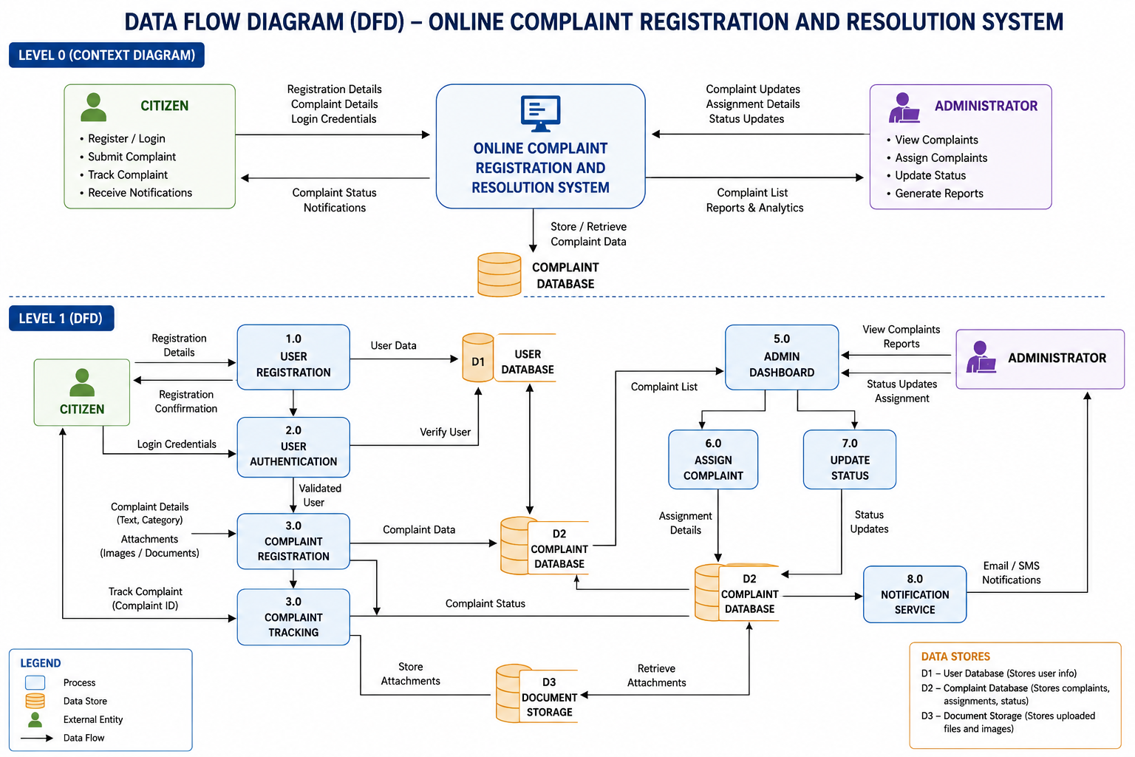

User Stories
User Story ID | Epic | User Story | Priority
US-01 | Registration | As a citizen, I want to register an account so that I can submit complaints. | High
US-02 | Login | As a citizen, I want to log in securely using my email and password. | High
US-03 | Complaint Registration | As a citizen, I want to submit a complaint with details and attachments. | High
US-04 | Complaint Tracking | As a citizen, I want to track the status of my complaint using its Complaint ID. | High
US-05 | Complaint History | As a citizen, I want to view all my previous complaints. | Medium
US-06 | Admin Dashboard | As an administrator, I want to view all registered complaints in one dashboard. | High
US-07 | Complaint Assignment | As an administrator, I want to assign complaints to the appropriate department or officer. | High
US-08 | Status Update | As an administrator, I want to update the complaint status (Pending, In Progress, Resolved). | High
US-09 | Notifications | As a citizen, I want to receive email/SMS notifications whenever my complaint status changes. | Medium
US-10 | Reports | As an administrator, I want to generate complaint reports and analytics. | Medium
US-11 | Profile Management | As a citizen, I want to edit my profile information. | Low
US-12 | Logout | As a user, I want to log out securely after using the system. | High

